**DAILY ONLINE ACTIVITIES SUMMARY**

|  |  |  |  |  |  |  |  |  |
| --- | --- | --- | --- | --- | --- | --- | --- | --- |
| **Date:** | **21-05-2020** | | | | | **Name:** | **SRILATHA K KAMATH** | |
| **Sem & Sec** | **6 B** | | | | | **USN:** | **4AL17CS099** | |
| **Online Test Summary** | | | | | | | | |
| **Subject** | | **OPERATING SYSTEMS IA TEST 1** | | | | | | |
| **Max. Marks** | | **30** | | **Score** | | | **30** | |
| **Certification Course Summary** | | | | | | | | |
| **Course** | **Career Edge – Knockdown the Lockdown** | | | | | | | |
| **Certificate Provider** | | | **TCS** | | **Duration** | | | **15days** |
| **Coding Challenges** | | | | | | | | |
| **Problem Statement:** Programs to implement Simple Calculator using applets and to implement Round Robin Algorithm in Java. | | | | | | | | |
| **Status: COMPLETED** | | | | | | | | |
| **Uploaded the report in Github** | | | | | **YES** | | | |
| **If yes Repository name** | | | | | https://github.com/alvas-education-foundation/Srilatha-K-Kamath-Daily-Report.git | | | |
| **Uploaded the report in slack** | | | | | **YES** | | | |

Online Test Details:

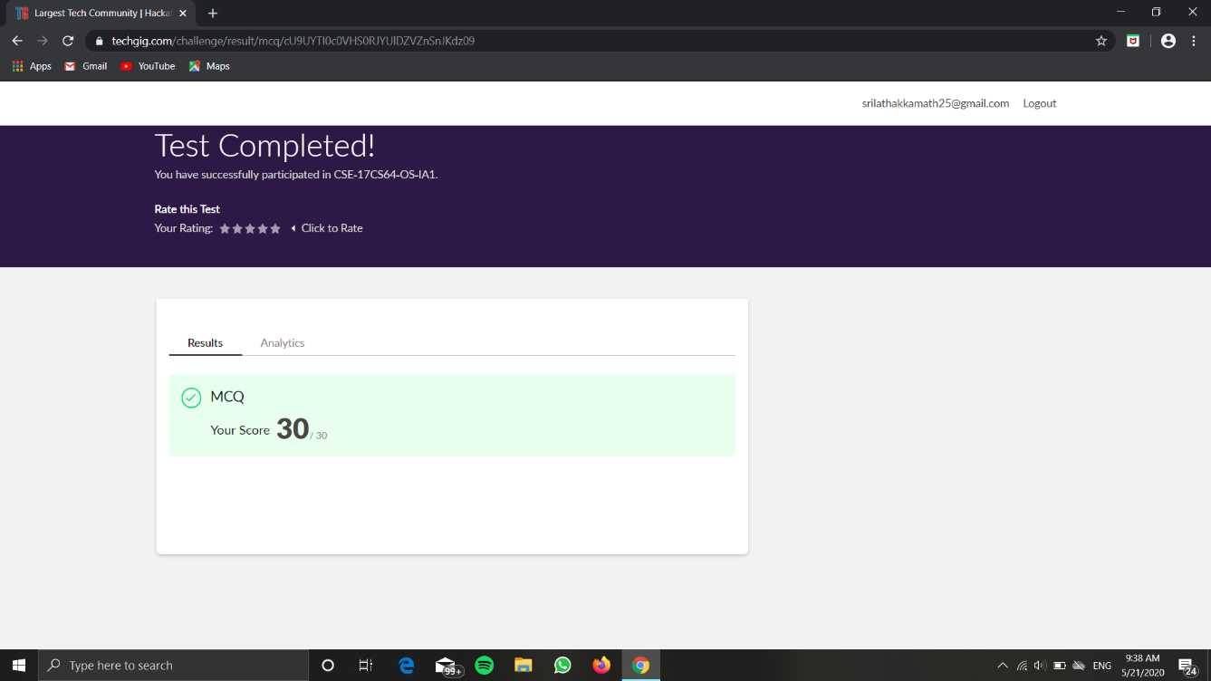

Online Course Details: 57.14% COMPLETED.

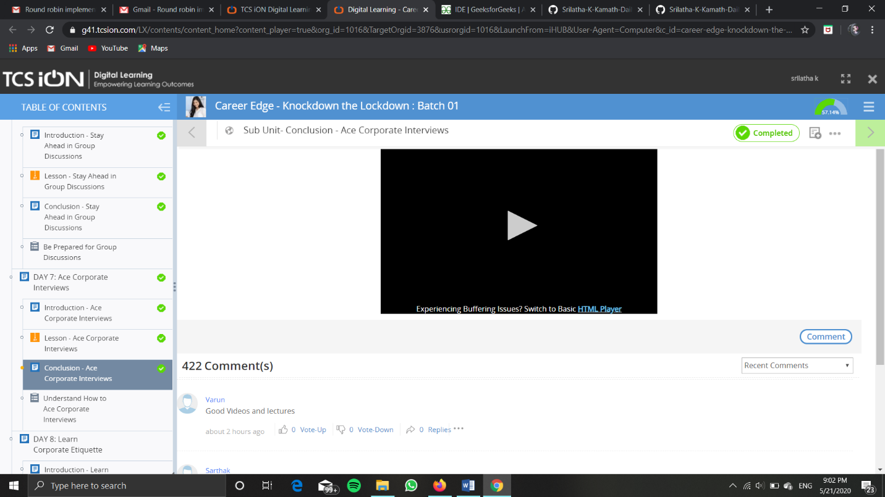

Online Coding Details: 